**Course _______Specialist______ Year __12_____**

Student name: ________________ Teacher name: ________________

Date: 24 Feb

**Task type: Response**

**Time allowed for this task: _____45______ mins**

**Number of questions: _____8______**

**Materials required:** Calculator with CAS capability (to be provided by the student)

Standard items: Pens (blue/black preferred), pencils (including coloured), sharpener, correction fluid/tape, eraser, ruler, highlighters

Special items: Drawing instruments, templates, notes on one unfolded sheet of   
A4 paper, and up to three calculators approved for use in the WACE examinations

**Marks available: __50____ marks**

**Task weighting: _10___%**

**Formula sheet provided: Yes**

**Note: All part questions worth more than 2 marks require working to obtain full marks.**

Q1 (3.1.1, 3.1.2, 3.1.3) (2, 2, 3 & 3 = 10 marks)

If  and  determine exactly the following. (Simplify)

1. 
2. 
3. 
4. 

Q2 (3.1.3) (3 marks)

Determine all possible real values of  such that 

Q3 (3.1.14, 3.1.15) (3& 3 = 6 marks)

Consider the quadratic equation  where  are real.

1. If one root of the above equation is  , determine .

Consider the equation  where  are real.

1. If the cubic equation above has roots , determine .

Q4 (3.1.3, 3.1.3, 3.1.3) (2 marks)

Determine  in the form  with . (Note: diagram not drawn to scale)

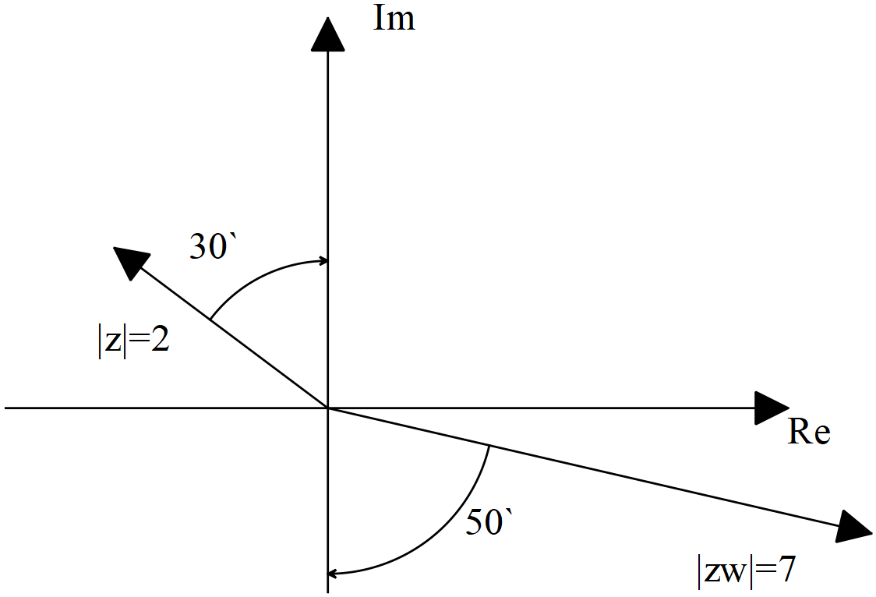

Q5 (3.1.10) (2, 2 & 3 = 7 marks)

Sketch the following regions in the complex plane showing major features.

1. 

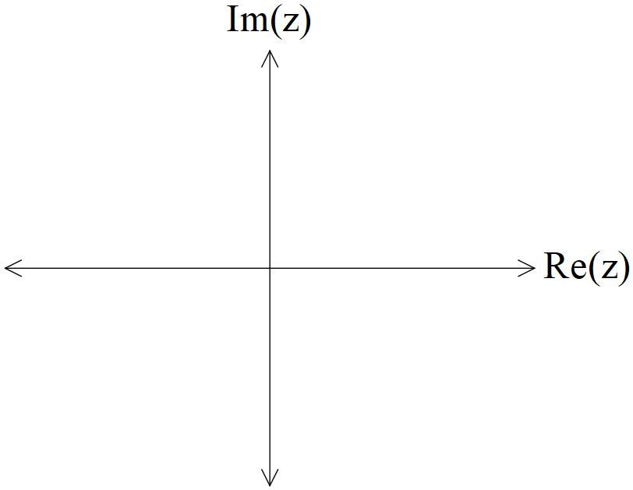

1. 



1. Consider all the complex numbers  that satisfy , determine the maximum possible value of , giving your answer in radians correct to two decimal places.

Q6 (3.1.7, 3.1.12) (4 & 3=7 marks)

1. Determine all the roots of  expressing in the form with .
2. Plot all of these roots on the diagram below.

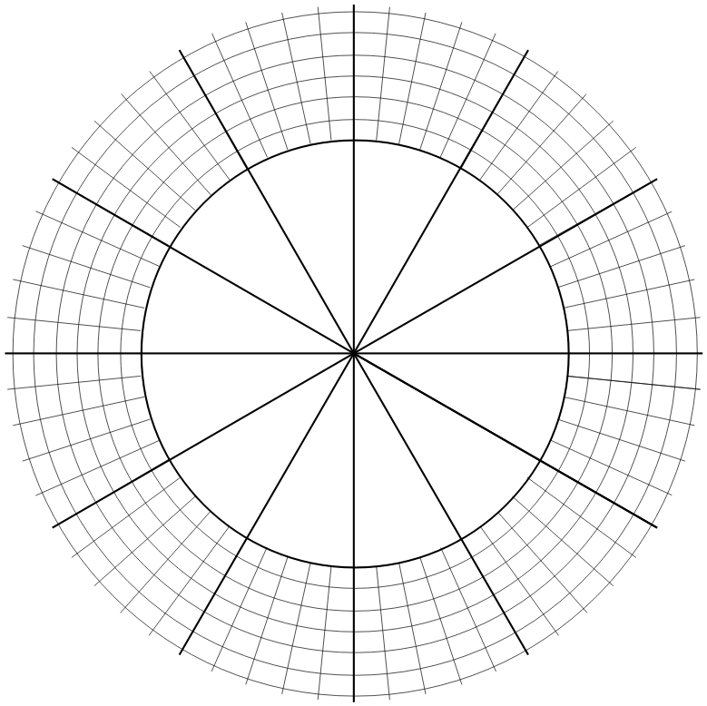

Q7 (3.2.1, 3.2.2) (1, 2, 2 & 2 = 7 marks)

Consider the functions .

1. Give the defining rule for .
2. Does exist over the natural domain of ? Explain
3. State the natural domain and range for .

Consider the function .

1. Does the function ? Justify your answer.

Q8 (3.2.3, 3.2.4) (2 , 3 & 3 = 8 marks)

Consider the function  drawn below.

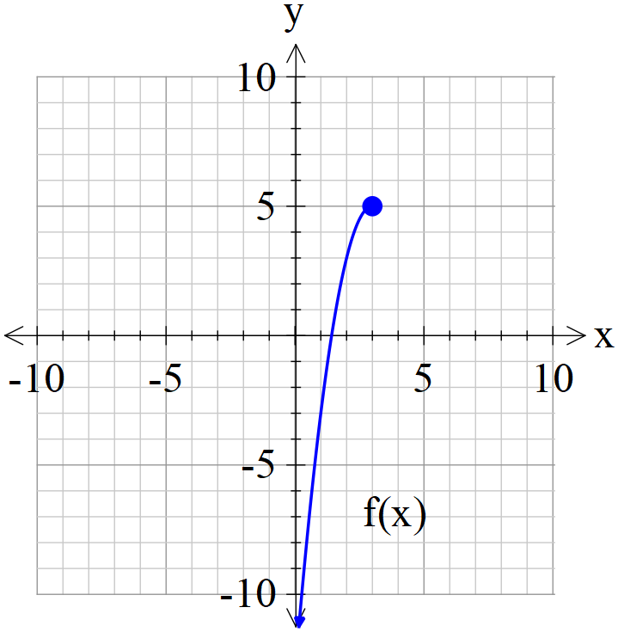

1. Sketch  on the axes above.
2. Given that , determine the defining rule for .

Show working for full marks.

1. Consider the function  where  is a positive constant. Solve in terms of , the solution(s) to .

**Working out space**